Daniel Dan-Ebbah

Assignment 2

Table of Contents

Introduction 3

Purpose of the Document 3

System Overview 3

Primary Users 3

Patients 3

Administrators 3

Key Features 3

Appointment Booking 3

Appointment Cancellation 3

Appointment Availability Inquiry: 3

Centralized Management for Administrators: 3

High-Level Architecture 4

System Architecture 4

Overview 4

Component Architecture 4

1. RMI Servers: 4

2. UDP Communication: 4

3. Client Applications: 4

Network Architecture 4

Communication Protocols: 5

Data Management 5

Data Replication and Synchronization: 5

Scalability and Fault Tolerance 5

Security Considerations 5

Logging and Monitoring 5

Project Structure 5

Steps to Run Application 9

# Introduction

## Purpose of the Document

This design documentation aims to provide a comprehensive overview of the Distributed Health Care Management System (DHMS). It is a reference for all, detailing the system's architecture, components, functionalities, and interaction flows. The document facilitates understanding, maintenance, and future enhancements of the DHMS.

## System Overview

The Distributed Health Care Management System (DHMS) is designed to streamline managing medical appointments across multiple hospitals within a medicare system. The system spans three major cities: Montreal, Quebec, and Sherbrooke, each with its server to handle local appointment data. DHMS enables patients to book, cancel, and inquire about appointments seamlessly, regardless of their preferred hospital location. Additionally, it allows hospital administrators to manage appointment slots, ensuring efficient utilization of medical resources.

## Primary Users

DHMS caters to two main user groups:

Patients: Individuals seeking to book, swap or cancel medical appointments across the participating hospitals. Patients can view available appointment slots and choose the most convenient time and location for their medical needs.

Administrators: Hospital staff responsible for managing the appointment schedule. They can add or remove appointment slots, adjust capacities, and view comprehensive appointment schedules across all locations.

## Key Features

DHMS offers a range of functionalities to improve the appointment management process, including:

Appointment Booking: Patients can book appointments at any participating hospital, with real-time visibility into slot availability.

Appointment Cancellation: Patients can cancel their appointments, automatically freeing up slots for other patients.

Appointment Availability Inquiry: Both patients and administrators can view available appointment slots across all hospitals, enabling informed decision-making.

Centralized Management for Administrators: Administrators can oversee and manage appointment slots, capacities, and schedules from a central interface, ensuring consistency and efficiency across the network.

## High-Level Architecture

The system employs Java Remote Method Invocation (RMI) for handling operations within individual hospitals and utilizes User Datagram Protocol (UDP) for inter-server communication to aggregate appointment availability data. This hybrid approach ensures robustness, scalability, and real-time data synchronization across the distributed system.

# System Architecture

## Overview

The architecture is built to support scalability, fault tolerance, and ease of maintenance, ensuring the system can effectively serve many users across different geographical locations.

## Component Architecture

The DHMS consists of several key components, each responsible for distinct aspects of the system's functionality:

### CORBA Servers:

**Function**: Each server instance represents a hospital in one of the participating cities (Montreal, Quebec, Sherbrooke) and handles local appointment operations such as booking, cancellation, and listing availability.

### UDP Communication:

**Function**: Facilitates inter-server communication to aggregate appointment availability information across all participating hospitals. This component is crucial for the `listAppointmentAvailability ` and `swapAppointment` feature, allowing patients and administrators to view available slots in all cities and swap for available slots meeting their schedule.

### Client Applications:

**Function**: Separate client applications for patients and administrators provide the user interface for interacting with the DHMS. Patient clients allow users to book, cancel, and view appointments, while administrator clients manage appointment slots and schedules.

## Network Architecture

The DHMS employs a distributed network architecture, with each server operating independently while also being capable of communicating with other servers in the network. This design supports high availability and ensures the system remains operational even if one or more servers become unavailable.

### Communication Protocols:

CORBA: Used for intra-city communication between clients and their local server, ensuring secure and reliable method invocation.

UDP: Facilitates inter-city communication among servers, primarily aggregating appointment availability data.

## Data Management

Each CORBA server maintains local data regarding appointments, patients, and administrators. For high performance, this data is managed using in-memory data structures (e.g., ConcurrentHashMap) and is protected by synchronization mechanisms to ensure thread safety and data consistency.

### Data Replication and Synchronization:

While each server maintains its data, certain operations require real-time data aggregation (e.g., listing city-wide appointment availability). UDP communication is used to query other servers and aggregate data on demand for these operations.

## Scalability and Fault Tolerance

With scalability in mind, new server instances can be added to the system to accommodate additional cities or hospitals with minimal configuration changes. Fault tolerance is achieved through the system's distributed nature, where the failure of a single server does not impact the overall system's availability or the functionality of other servers.

## Security Considerations

Authentication: Ensures that only authorized users can access and perform operations within the system.

Data Encryption: Protects sensitive data during transmission, mainly when using RMI and UDP communication channels.

## Logging and Monitoring

A centralized logging mechanism captures system events, errors, and operational metrics. This aids in monitoring system health, performance optimization, and troubleshooting.

## Project Structure

* **Client**: Stores all the client files for RMI clients
* **Database**: Stores the instance of hashmaps, which acts as a database for the project. The `HashMap.java` is the high-level class from which other city instance hashmaps are based. It holds all the necessary operations to maintain the database (hashmap)
* **Model**: This is the home to all enums and object classes needed throughout the application.
* **Server**: Stores all the server files for both UDP and RMI clients
* **Util: stores** the file that configures the logs and a helper class.

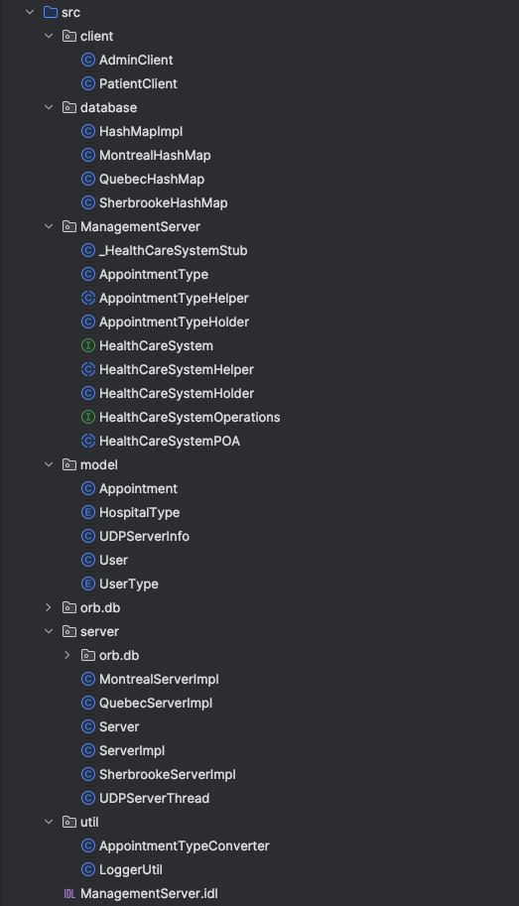 FIG 1 – Project Structure

FIG 2 – UM Diagram of Application

## Steps to Run Application

1. Start the Object Request Broker Daemon (ORBD)
2. Run the Server class: as that will start both the CORBA and UDP servers.
3. Run the AdminClient.java and PatientClient.java files
4. Select the operations to perform select (4) to exit.

